4. Memory Management
python
def remember(self, state, action, reward, next_state, gameover): self.memory.append((state, action, reward, next_state, gameover))
Stores experiences for later learning. The deque automatically removes oldest entries when it reaches 100,000 items.

- dtype=torch.float: 32-bit floating-point numbers (for state and reward)
- dtype=torch.long: 64-bit integers (for action indices, used in classification/selection

5. Training Functions
python
def train_long_memory(self):
if len(self.memory) > BATCH_SIZE:
mini_sample = random.sample(self.memory, BATCH_SIZE)
else:
mini_sample = self.memory
This is Experience Replay:
- Takes random batch of 1000 past experiences
- Trains the model on these old experiences (improves stability)
- Not connected to trainer yet (incomplete)
python
def train_short_memory(self, state, action, reward, next_state, gameover):
self.trainer.train_step(state, action, reward, next_state, gameover)
Trains immediately after each game step on this single experien

Short vs Long Memory Comparison
Aspect | SHORT Memory | LONG Memory
When | After EVERY move | After game ends
What | Train on 1 experience | Train on random 1000 experiences
Speed | Fast, immediate | Slower, but more stable
Purpose | Quick learning | Better overall patterns

After zip(*mini_sample): What Happens?
The * unpacks the list, and zip() reorganizes it:
python
# BEFORE (organized by experience):
mini_sample = [
(s1, a1, r1, ns1, d1),
(s2, a2, r2, ns2, d2),
(s3, a3, r3, ns3, d3),
]

# AFTER zip(*mini_sample):
states = (s1, s2, s3, ...) ← All states together
actions = (a1, a2, a3, ...) ← All actions together
rewards = (r1, r2, r3, ...) ← All rewards together
next_states = (ns1, ns2, ns3, ...) ← All next states together
dones = (d1, d2, d3, ...) ← All dones together

Epsilon ValueBehavior

ε = 1.0Always random (100% explore)
ε = 0.550% random, 50% smart
ε = 0.190% smart, 10% random
ε = 0.0Always smart (0% explore)

Game 1: n_games = 1, epsilon = 80 - 1 = 79 (79% explore)
Game 2: n_games = 2, epsilon = 80 - 2 = 78 (78% explore)
Game 10: n_games = 10, epsilon = 80 - 10 = 70 (70% explore)
Game 50: n_games = 50, epsilon = 80 - 50 = 30 (30% explore)
Game 80: n_games = 80, epsilon = 80 - 80 = 0 (0% explore - fully trained)

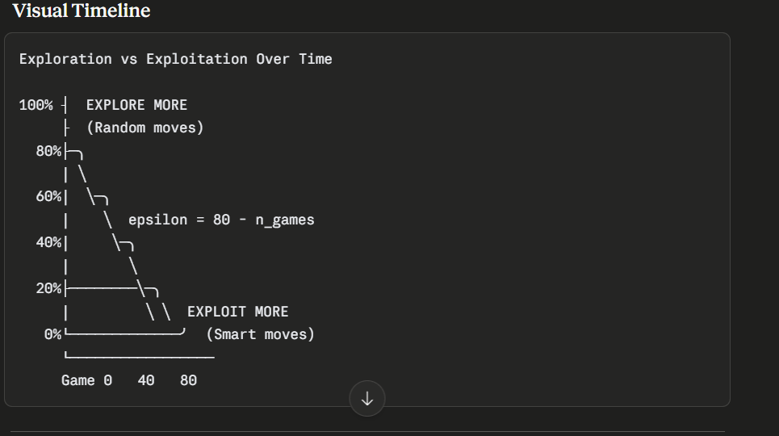
• After 80 games, epsilon reaches 0
• After 80 games, the AI stops exploring randomly
• 80 games = enough time to learn pattern

Line 2: Initialize Action Vector

final_move = [0, 0, 0]
Creates a vector representing the 3 possible moves for Snake:
[0, 0, 0] → No action (straight)
[1, 0, 0] → Turn LEFT
[0, 1, 0] → Go STRAIGHT
[0, 0, 1] → Turn RIGHT
This is one-hot encoding (only one position is 1, rest are 0).

if random.randint(0, 200) < self.epsilon:
This is the exploration vs exploitation decision.
Breaking It Down:
python
random.randint(0, 200) # Generates random number: 0, 1, 2, ..., 199, 200
# 201 possible values

self.epsilon # Exploration rate (0 to 80)
How It Works:
Example 1: Early Game (Game 1)
python
self.epsilon = 79
random.randint(0, 200) = ?

Probability of condition being True:
79 / 201 = 39.3% ← Explore

Probability of condition being False:
122 / 201 = 60.7% ← Exploit
Example 2: Middle Game (Game 40)
python
self.epsilon = 40
random.randint(0, 200) = ?

Probability of condition being True:
40 / 201 = 19.9% ← Explore

Probability of condition being False:
161 / 201 = 80.1% ← Exploit
Example 3: Late Game (Game 80+)
python
self.epsilon = 0 (or negative)
random.randint(0, 200) = ?

Probability of condition being True:
0 / 201 = 0% ← Never explore

Probability of condition being False:
201 / 201 = 100% ← Always exploit (use model)

With 200:
python
self.epsilon = 80

# Probability of exploring:
Favorable outcomes: 0 to 79 (80 numbers)
Total outcomes: 0 to 200 (201 numbers)
Probability = 80/201 = 39.8% ← Explore

# Probability of exploiting:
Probability = 121/201 = 60.2% ← Exploit

Why This Specific Condition?
The Key Insight:
When epsilon is HIGH (early games):
- More random numbers fall below epsilon
- More likely to explore
When epsilon is LOW (late games):
- Fewer random numbers fall below epsilon
- Less likely to explore

Exploration triggered: random < epsilon = TRUE
# Step 1: Pick random move move = random.randint(0, 2)
# Possibility 1: move = 0 move = 0 final_move = [0, 0, 0] final_move[move] = 1 # final_move[0] = 1 final_move = [1, 0, 0] ← TURN LEFT
# Possibility 2: move = 1 move = 1 final_move = [0, 0, 0] final_move[move] = 1 # final_move[1] = 1 final_move = [0, 1, 0] ← GO STRAIGHT
# Possibility 3: move = 2 move = 2 final_move = [0, 0, 0] final_move[move] = 1 # final_move[2] = 1 final_move = [0, 0, 1] ← TURN RIGHT # Each has ~33% chance of being picked

What's happening:
- unsqueeze(dim=0) adds a batch dimension at position 0
- Neural networks expect batches: (batch_size, features)
- A single sample needs to be treated as a batch of size 1
Example:
python
state = torch.tensor([0.5, -0.2, 1.3]) # Shape: (3,)state = torch.unsqueeze(state, 0) # Shape: (1, 3)# Now it's a batch with 1 sample of 3 features

What is state?
python
state = agent.get_state(game)
# Returns: numpy array
# Example: array([0, 1, 0, 1, 0, 0, 0, 1, 1, 0, 1])
# Type: <class 'numpy.ndarray'>
The Problem: Type Mismatch
python
# ❌ If we do this directly:
prediction = self.model.predict(state)
The neural network expects a PyTorch tensor, but state is a numpy array.
state: numpy.ndarray [0, 1, 0, 1, ...]
↓
model: Expects torch.tensor
↗ TYPE MISMATCH! ❌
The Solution: Convert to PyTorch Tensor
python
# ✅ Correct: Convert first
state0 = torch.tensor(state, dtype=torch.float)
# ↑ ↑ ↑
# PyTorch Input Data type
# function (numpy) (float)

prediction = self.model.predict(state0)

The Problem
python
state = [0.5, -0.2, 1.3]Shape: (3,)
Looking at this shape, we can't tell:
- Is this 1 sample with 3 features?
- Or is this 3 samples with 1 feature each?
Option A: Option B:[0.5, -0.2, 1.3] [[0.5], [-0.2], [1.3]]1 sample 3 samples3 features 1 feature each
It's AMBIGUOUS! 😕

The Solution
python
state = [[0.5, -0.2, 1.3]]Shape: (1, 3) ↓ ↓ batch features
Now it's CLEAR:
- First dimension = 1 → Batch size of 1 (1 sample)
- Second dimension = 3 → 3 features (0.5, -0.2, 1.3)

